Solved papers of bt101 year 2018
(all answers are searched from google)
Red tides?
Red tide is a phenomenon caused by algal blooms (Wikipedia definition) during which algae become so numerous that they discolor coastal waters (hence the name "red tide"). The algal bloom may also deplete oxygen in the waters and/or release toxins that may cause illness in humans and other animals.
Genetic diversity?
Genetic diversity is the total number of genetic characteristics in the genetic makeup of a species. It is distinguished from geneticvariability, which describes the tendency of genetic characteristics to vary. Genetic diversity serves as a way for populations to adapt to changing environments.
Aquatic and terrestrial biomes?
Biomes are large regions characterized by a specific type of climate and certain types of plant and animal communities.
Each biome is made up of many individual ecosystems.
some of the major terrestrial biomes in the world; tropical forests, savannas, deserts, temperate grasslands, temperate deciduous forests, Mediterranean scrub, coniferous forests, and tundra
The aquatic biome is definitely the largest biome out there. Water covers nearly 75 percent of the earth's surface, in the form of oceans, lakes, rivers, etc. Just like all other biomes, the aquatic biome can be divided into two categories: freshwater regions and saltwater regions.
Neurospora and its uses?
Neurospora is a genus of Ascomycete fungi. The genus name, meaning "nerve spore" refers to the characteristic striations on the spores that resemble axons.
The best known species in this genus is Neurospora crassa, a common model organism in biology. Neurospora intermedia var. oncomensis is believed to be the only mold belonging to Neurospora which is used in food production
Neurospora is widely used in genetics as a model organism (especially N. crassa) because it is quickly reproducing, is easy to culture,^{[4]} and can survive on minimal media (inorganic salts, glucose, water and biotin in agar).
Long question?
Reproductive cycle of fungi?
In the life cycle of a sexually reproducing fungus, a haploid phase alternates with a diploid phase. The haploid phase ends with nuclear fusion, and the diploid phase begins with the formation of the zygote (the diploid cell resulting from fusion of two haploid sex cells). Meiosis (reduction division) restores the haploid number of chromosomes and initiates the haploid phase, which produces the gametes. In the majority of fungi, all structures are haploid except the zygote. Nuclear fusion takes place at the time of zygote formation, and meiosis follows immediately. Only in Allomyces and a few related genera and in some yeasts is alternation of a haploid thallus with a diploid thallus definitely known.
Coevolution with example?
When organisms that are ecologically intimate -- for example, predators and prey, or hosts and parasites -- influence each other's evolution, we say that coevolution is occurring. Birds are often important actors in coevolutionary systems. For example, predation by birds largely drives the coevolution of model and mimetic butterflies. Some butterflies have evolved the ability to store poisonous chemicals from the food plants they eat as caterpillars, thus becoming distasteful. This reduces their chances of being eaten, since birds, once they have tried to devour such butterflies, will avoid attacking them in the future. Other butterflies have gradually evolved color patterns that mimic those of the distasteful butterflies (called "models"). It is disadvantageous for the models to be mimicked, because if the mimics become common then most of the butterflies with the model's color pattern taste good, the birds may resume attacking the models. Being tasted and spit out by a bird is a most dangerous experience for a butterfly. Therefore, mimicry presumably leads to a coevolutionary race -- the mimics evolving toward the color patterns of the models, and the models evolving away from the converging mimics. The birds actually may be directly involved in the entire coevolutionary complex, since they may be under selection for better powers of discrimination. Individuals that can tell the mimetic butterflies from the models will gain more nourishment at less cost in time and effort.
Types of protozoans?
1. Sarcodina:
Motility is due to the streaming of ectoplasm, producing protoplasmic projections called pseudopodia (false feet). Examples: Free-living form like Amoeba proteus* and parasitic form like Entamoeba histolytica*.
2. Mastigophora:
Locomotion is effected by one or more whip-like, thin structures called flagella. Examples: Free- living forms like Euglena viridis*, Cercomonas longicauda*, Heteronema acus* and parasitic forms like Trichomonas vaginalis, Trypanosoma gambiense*, Giardia lamblia*.

3. Ciliophora:
Locomotion is carried out by means of short hair-like projections called cilia, whose synchronous beating propels the organisms. Examples: Free-living forms like Paramecium caudatum*, Stentor polymorpha*, Vorticella campanula* and parasitic form like Balantidium coli*.Locomotion is effected by one or more whip-like, thin structures called flagella. Examples: Free- living forms like Euglena viridis*, Cercomonas longicauda*, Heteronema acus* and parasitic forms like Trichomonas vaginalis, Trypanosoma gambiense*, Giardia lamblia*.
4. Sporozoa:
Unlike the above three classless of protozoa, members of the class sporozoa do not have locomotor organelles in their mature stage; however, immature forms exhibit some type of movement. All the members of this group are parasites.
Examples: Plasmodium, the malarial parasites of animals and human beings.

Types of Protozoa:

Based on the mode of nutrition, protozoa are of the following two types:
1. Free-living protozoa: They ingest particulates, such as bacteria, yeast and algae.
2. Parasitic protozoa: They derive nutrients from the body fluids of their hosts.
2.growth forms of lichens 10
- crustose - crustlike, growing tight against the substrate.
- squamulose - tightly clustered and slightly flattened pebble-like units.
- foliose - leaflike, with flat sheets of tissue not tightly bound.
- fruticose - free-standing branching tubes.
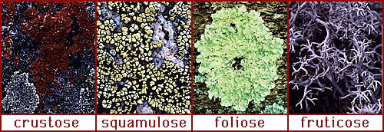
Despite the wide diversity of the basic growth forms, all lichens have a similar internal morphology. The bulk of the lichen's body is formed from filaments of the fungal partner, and the relative density of these filaments defines the layers within the lichen.
At its outer surface, where it comes in contact with the environment, the filaments are packed tightly together to form the cortex. The dense cortex serves to keep out other organisms, and helps to reduce the intensity of light which may damage the alga cells.
The algal partner cells are distributed just below the cortex in a layer where the fungal filaments are not so dense. This is very similar to the arangement in a plant leaf, where the photosynthetic cells are loosely packed to allow air circulation.
Below the algal layer is the medulla, a loosely woven layer of fungal filaments. In foliose lichens, there is a second cortex below the medulla, but in crustose and squamulose lichens, the medulla is in direct contact with the underlying substrate, to which the lichen is attached.
3.global warming 5
A protective layer in the atmosphere that protects
the life on earth from harmful effects of
ultraviolet radiations from sun is known as
Ozone layer. It contains high concentrations of
Ozone (O3)
On the base of production ozone is divided into
two types,
▪ Stratospheric ozone
▪ Tropospheric ozone
Stratospheric ozone:
In the first step, solar
ultraviolet
radiation
breaks apart one
oxygen molecule (O3)
to produce two oxygen
atoms.
Tropospheric ozone:
Nitrogen compounds released from automobiles
is broken down by sunlight into nitrogen oxide
(NO2). It is then converted in to nitrogen
monoxide (NO), releasing an oxygen molecule
that combines with oxygen(O2) in the
atmosphere to form Ozone (O3).
4. invasive species 5
An invasive species is a plant, fungus, or animal species that is not native to a specific location (an introduced species), and which has a tendency to spread to a degree believed to cause damage to the environment, human economy or human health.^{[1][dubious – discuss]}
One study pointed out widely divergent perceptions of the criteria for invasive species among researchers (p. 135) and concerns with the subjectivity of the term "invasive" (p. 136).^{[2]} Some of the alternate usages of the term are below:
- The term as most often used applies to introduced species (also called "non-indigenous" or "non-native") that adversely affect the habitats and bioregions they invade economically, environmentally, or ecologically. Such invasive species may be either plants or animals and may disrupt by dominating a region, wilderness areas, particular habitats, or wildland–urban interface land from loss of natural controls (such as predators or herbivores). This includes non-native invasive plant species labeled as exotic pest plants and invasive exotics growing in native plant communities.
5. Counter shading with two examples
Countershading is a type of coloration commonly found in animals and means that the animal's back (dorsal side) is dark while its underside (ventral side) is light. This shading helps an animal blend in with its surroundings.
Examples:
In the ocean, countershading camouflages an animal from predators or prey. When viewed from below, an animal's lighter belly would blend in with the lighter sky above. When viewed from above, its darker back would blend in with the ocean bottom underneath.
Grey reef shark exhibits countershading whose underbody is lighter in color and upper part is darker grey.
Caterpillar Actias luna exhibits bright green color on the back’s side while darker green color on the ventral side.
6.bad things in linnaues two kingdom system?
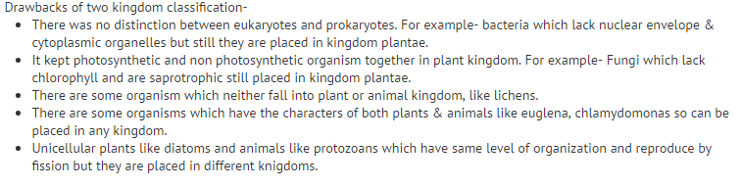
7.define red tide
(given above)
8.define genetic diversity
Genetic diversity is the total number of geneticcharacteristics in the genetic makeup of a species. It is distinguished from genetic variability, which describes the tendency of genetic characteristics to vary. Genetic diversity serves as a way for populations to adapt to changing environments.
9.two major forms of symbiosis
Commensalism: a relationship where one specie gets benefit while the other does not get any benefit or harm.
Mutualism: a relationship where both species benefit from the relation.
1.define pellicle
a thin layer supporting the cell membrane in various protozoa. Pellicle mirror, a thin plastic membrane which may be used as a beam splitter or protective cover in optical systems.
3.after effects of forest removal.(10 marks)
Deforestation can have a negative impact on the environment. The most dramatic impact is a loss of habitat for millions of species. Eighty percent of Earth’s land animals and plants live in forests, and many cannot survive the deforestation that destroys their homes.
Deforestation also drives climate change. Forest soils are moist, but without protection from sun-blocking tree cover, they quickly dry out. Trees also help perpetuate the water cycle by returning water vapor to the atmosphere. Without trees to fill these roles, many former forest lands can quickly become barren deserts.
Removing trees deprives the forest of portions of its canopy, which blocks the sun’s rays during the day, and holds in heat at night. This disruption leads to more extreme temperature swings that can be harmful to plants and animals.
Trees also play a critical role in absorbing the greenhouse gases that fuel global warming. Fewer forests means larger amounts of greenhouse gasesentering the atmosphere—and increased speed and severity of global warming.
The most feasible solution to deforestation is to carefully manage forest resources by eliminating clear-cutting to make sure forest environments remain intact. The cutting that does occur should be balanced by planting young trees to replace older trees felled. The number of new tree plantations is growing each year, but their total still equals a tiny fraction of the Earth’s forested land.
Top of Form
Bottom of Form
4 nitrogen cycle steps.(10 marks)
The Nitrogen Cycle
Organisms require nitrogen to produce amino acids. Nitrogen makes up seventy-eight percent of the atmosphere, but most organisms can not use this form of nitrogen, and must have the fixed form. The nitrogen cycle produces the fixed form of nitrogen these organisms need.
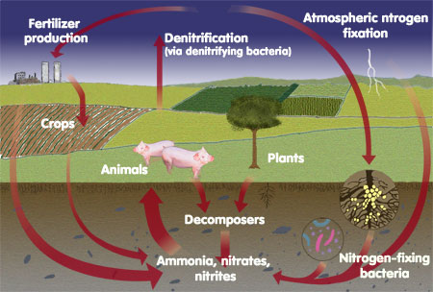
Step 1: A special type of bacteria called nitrogen fixing bacteria take in atmospheric nitrogen and produce ammonia (NH₃).
Step 2: Other bacteria use this ammonia to produce nitrates and nitrites, which are nitrogen and oxygen containing compounds.
Step 3: The nitrates and nitrites are used by plants to make amino acids which are then used to make plant proteins.
Step 4: Plants are consumed by other organisms which use the plant amino acids to make their own.
Step 5: Decomposers convert the nitrogen found in other organisms into ammonia and return it to the soil. A few of these type of bacteria return nitrogen to the atmosphere by a process called denitrification, however this amount is small.
6.define mimicry with examples.
. Mimicry occurs when one animal displays physical or behavioral traits that copy those of a different species or their surroundings, and incur a survival advantage on account of it. Animals don't necessarily mimic other animals; often, they mimic plants or rocks.
.Amphibians and reptiles are also an excellent example of mimicry.There are reptiles which people immediately can remember when mimicry is mentioned.It is a chameleon, the lizard who changes its colors according to the environment that surrounds him. That is the best way to protect themselves but also to catch their lunch.
Many beetles can have vibrant colors that can easily drive off the enemy.On this bug colors are so deployed give us the impression that we look into being with large eyes and mouth filled with sharp say teeth.
7.define coevolution with examples 5 marks.
(Given above)
8.define genetic diversity
(Given above)
M.c.q's:
1.common carp is an example of.....
2.humming bird and insect pollinated is an example of....
3.word ecosystem was coined by....
4......high biotic potential.(large animals or small animals.)
5.small organims have (high population density.)
6.beaver is an example of....
7.non-native spp. are introduced through.....
8.tropical rain forest covers area.....
9.main cause of habitat loss is.....
10.cage song birds is an example of....
11.how many types of mutualisms are....
12.biomes have elements.....
13.main cause of ozone depletion....
14.SO2 released in year 1991 (20.000.000)
15.one blank related to global warming definition.....
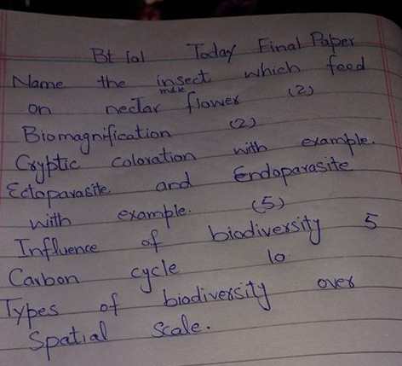
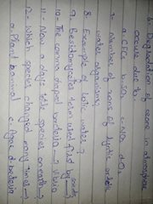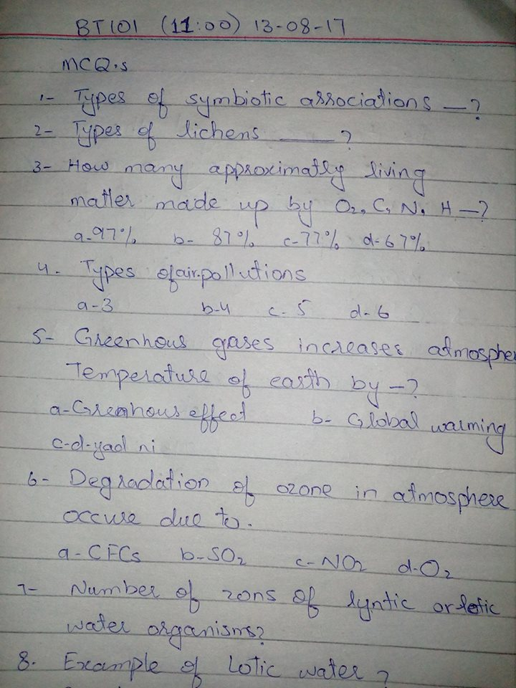
1- symbionts forms2
Given above
2- taxonomic forms of slime molds 2
Slime molds can generally be divided into two main groups.
- A plasmodial slime mold is enclosed within a single membrane without walls and is one large cell. This "supercell" (a syncytium) is essentially a bag of cytoplasm containing thousands of individual nuclei. See heterokaryosis.
- By contrast, cellular slime molds spend most of their lives as individual unicellular protists, but when a chemical signal is secreted, they assemble into a cluster that acts as one organism. (not confirm.. do confirm from ppts)
3-genetic diversity 2
Given above
4-lineaus kingdom shortcomes 3
Given above
5-pollutant types 3
degradable and non-degradable pollutants
6- effects of water pollution 5
Death of aquatic (water) animals
The main problem caused by water pollution is that it kills organisms that depend on these water bodies. Dead fish, crabs, birds and sea gulls, dolphins, and many other animals often wind up on beaches, killed by pollutants in their habitat (living environment).
Disruption of food-chains
Pollution disrupts the natural food chain as well. Pollutants such as lead and cadmium are eaten by tiny animals. Later, these animals are consumed by fish and shellfish, and the food chain continues to be disrupted at all higher levels.
7-value of biodiversity 5
Search ppts
8-nitrogen cycle 10
Given above
9- types of biodiversity over spatial scale
Search ppts
name of insect fed on male flower's nector (2)
Bumble bee, hawkmoth, anopheles mosquito,
define eutrophication(2)
excessive richness of nutrients in a lake or other body of water, frequently due to run-off from the land, which causes a dense growth of plant life.
what is e1-nino (3)
type of short come climate change which occurs every two to seven years around Christmas time when the typical weather pattern in the pacific ocean breaks down.
how solid wastes are managed (10)
Search ppts
what is ozone ? how it is formed (10)
(read pg #370-375 of ppts)
write three growth forms of lichens and benefits of lichens (5)
Growth forms are given above., benefits are:
Many lichens are very sensitive to environmental disturbances and can be used in cheaply assessing air pollution, ozone depletion, and metal contamination. Lichenshave been used in making dyes, perfumes, and in traditional medicines. A few lichen species are eaten by insects or larger animals, such as reindeer

